 

# Lecture-1 Introduction of Computer Network

# What is a Computer Network?

* **Computer Network** is a group of computers connected with each other through wires, optical fibres or optical links so that various devices can interact with each other through a network.
* The aim of the computer network is the sharing of resources among various devices.
* In the case of computer network technology, there are several types of networks that vary from simple to complex level.

## Components of Computer Network:

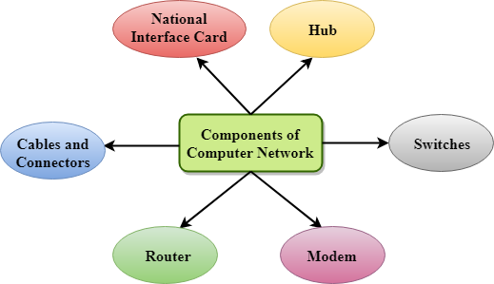

# Computer Network Components

Computer network components are the *major parts* which are needed to *install the software*. Some important network components are **NIC**, **switch**, **cable**, **hub**, **router**, and **modem**. Depending on the type of network that we need to install, some network components can also be removed. For example, the wireless network does not require a cable.

Following are the major components required to install a network:

## NIC

* NIC stands for network interface card.
* NIC is a hardware component used to connect a computer with another computer onto a network
* It can support a transfer rate of 10,100 to 1000 Mb/s.
* The MAC address or physical address is encoded on the network card chip which is assigned by the IEEE to identify a network card uniquely. The MAC address is stored in the PROM (Programmable read-only memory).

### There are two types of NIC:

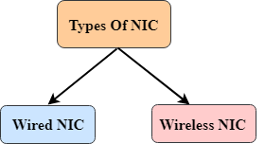

1. Wired NIC
2. Wireless NIC

**Wired NIC:** The Wired NIC is present inside the motherboard. Cables and connectors are used with wired NIC to transfer data.

**Wireless NIC:** The wireless NIC contains the antenna to obtain the connection over the wireless network. For example, laptop computer contains the wireless NIC.

## Hub

A Hub is a hardware device that divides the network connection among multiple devices. When computer requests for some information from a network, it first sends the request to the Hub through cable. Hub will broadcast this request to the entire network. All the devices will check whether the request belongs to them or not. If not, the request will be dropped.

The process used by the Hub consumes more bandwidth and limits the amount of communication. Nowadays, the use of hub is obsolete, and it is replaced by more advanced computer network components such as Switches, Routers.

## Switch

A switch is a hardware device that connects multiple devices on a computer network. A Switch contains more advanced features than Hub. The Switch contains the updated table that decides where the data is transmitted or not. Switch delivers the message to the correct destination based on the physical address present in the incoming message. A Switch does not broadcast the message to the entire network like the Hub. It determines the device to whom the message is to be transmitted. Therefore, we can say that switch provides a direct connection between the source and destination. It increases the speed of the network.

Router

* A router is a hardware device which is used to connect a LAN with an internet connection. It is used to receive, analyze and forward the incoming packets to another network.
* A router works in a **Layer 3 (Network layer)** of the OSI Reference model.
* A router forwards the packet based on the information available in the routing table.
* It determines the best path from the available paths for the transmission of the packet.

### Advantages of Router:

* **Security:** The information which is transmitted to the network will traverse the entire cable, but the only specified device which has been addressed can read the data.
* **Reliability:** If the server has stopped functioning, the network goes down, but no other networks are affected that are served by the router.
* **Performance:** Router enhances the overall performance of the network. Suppose there are 24 workstations in a network generates a same amount of traffic. This increases the traffic load on the network. Router splits the single network into two networks of 12 workstations each, reduces the traffic load by half.

## Modem

* A modem is a hardware device that allows the computer to connect to the internet over the existing telephone line.
* A modem is not integrated with the motherboard rather than it is installed on the slot found on the motherboard.
* It stands for Modulator/Demodulator. It converts the digital data into an analog signal over the telephone lines.

Based on the differences in speed and transmission rate, a modem can be classified in the following categories:

* Standard PC modem or Dial-up modem
* Cellular Modem
* Cable modem

Cables and connectors

Cable is a transmission media that transmits the communication signals. **There are three types of cables:**

* **Twisted pair cable:** It is a high-speed cable that transmits the data over **1Gbps** or more.
* **Coaxial cable:** Coaxial cable resembles like a TV installation cable. Coaxial cable is more expensive than twisted pair cable, but it provides the high data transmission speed.
* **Fibre optic cable:** Fibre optic cable is a high-speed cable that transmits the data using light beams. It provides high data transmission speed as compared to other cables. It is more expensive as compared to other cables, so it is installed at the government level.

## Uses of Computer Network

* **Resource sharing:** Resource sharing is the sharing of resources such as programs, printers, and data among the users on the network without the requirement of the physical location of the resource and user.
* **Server-Client model:** Computer networking is used in the **server-client model**. A server is a central computer used to store the information and maintained by the system administrator. Clients are the machines used to access the information stored in the server remotely.
* **Communication medium:** Computer network behaves as a communication medium among the users. For example, a company contains more than one computer has an email system which the employees use for daily communication.
* **E-commerce:** Computer network is also important in businesses. We can do the business over the internet. For example, amazon.com is doing their business over the internet, i.e., they are doing their business over the internet.

# Features of Computer network

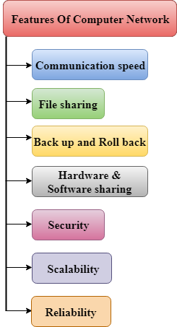

A list Of Computer network features is given below.

* Communication speed
* File sharing
* Back up and Roll back is easy
* Software and Hardware sharing
* Security
* Scalability
* Reliability

### Communication speed

Network provides us to communicate over the network in a fast and efficient manner. For example, we can do video conferencing, email messaging, etc. over the internet. Therefore, the computer network is a great way to share our knowledge and ideas.

### File sharing

File sharing is one of the major advantage of the computer network. Computer network provides us to share the files with each other.

### Back up and Roll back is easy

Since the files are stored in the main server which is centrally located. Therefore, it is easy to take the back up from the main server.

Software and Hardware sharing

We can install the applications on the main server, therefore, the user can access the applications centrally. So, we do not need to install the software on every machine. Similarly, hardware can also be shared.

### Security

Network allows the security by ensuring that the user has the right to access the certain files and applications.

### Scalability

Scalability means that we can add the new components on the network. Network must be scalable so that we can extend the network by adding new devices. But, it decreases the speed of the connection and data of the transmission speed also decreases, this increases the chances of error occurring. This problem can be overcome by using the routing or switching devices.

### Reliability

Computer network can use the alternative source for the data communication in case of any hardware failure.

# Computer Network Architecture

Computer Network Architecture is defined as the physical and logical design of the software, hardware, protocols, and media of the transmission of data. Simply we can say that how computers are organized and how tasks are allocated to the computer.

**The two types of network architectures are used:**

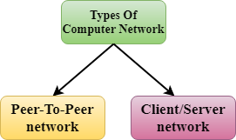

* Peer-To-Peer network
* Client/Server network

## Peer-To-Peer network

* Peer-To-Peer network is a network in which all the computers are linked together with equal privilege and responsibilities for processing the data.
* Peer-To-Peer network is useful for small environments, usually up to 10 computers.
* Peer-To-Peer network has no dedicated server.
* Special permissions are assigned to each computer for sharing the resources, but this can lead to a problem if the computer with the resource is down.

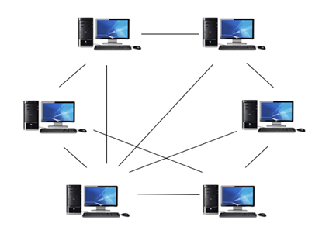

### Advantages of Peer-To-Peer Network:

* It is less costly as it does not contain any dedicated server.
* If one computer stops working but, other computers will not stop working.
* It is easy to set up and maintain as each computer manages itself.

### Disadvantages of Peer-To-Peer Network:

* In the case of Peer-To-Peer network, it does not contain the centralized system. Therefore, it cannot back up the data as the data is different in different locations.
* It has a security issue as the device is managed itself.

## Client/Server Network

* Client/Server network is a network model designed for the end users called clients, to access the resources such as songs, video, etc. from a central computer known as Server.
* The central controller is known as a **server** while all other computers in the network are called **clients**.
* A server performs all the major operations such as security and network management.
* A server is responsible for managing all the resources such as files, directories, printer, etc.
* All the clients communicate with each other through a server. For example, if client1 wants to send some data to client 2, then it first sends the request to the server for the permission. The server sends the response to the client 1 to initiate its communication with the client 2.

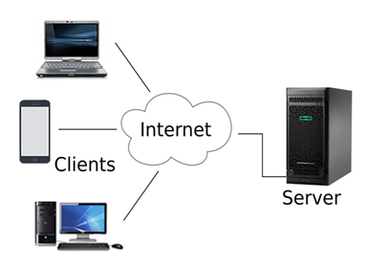

### Advantages of Client/Server network:

* A Client/Server network contains the centralized system. Therefore we can back up the data easily.
* A Client/Server network has a dedicated server that improves the overall performance of the whole system.
* Security is better in Client/Server network as a single server administers the shared resources.
* It also increases the speed of the sharing resources.

### Disadvantages of Client/Server network:

* Client/Server network is expensive as it requires the server with large memory.
* A server has a Network Operating System (NOS) to provide the resources to the clients, but the cost of NOS is very high.
* It requires a dedicated network administrator to manage all the resources.

# 